GCSE Higher Level Data 2 Extra information

Data set 1

The cumulative frequency graph shows the length of time taken by a group of students to complete an exam:

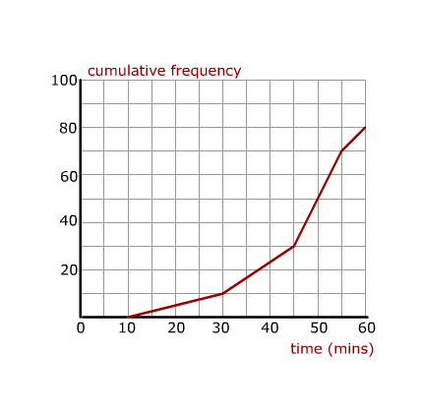

Data set 2

The heights of a group of plants were recorded and put into a cumulative frequency graph.

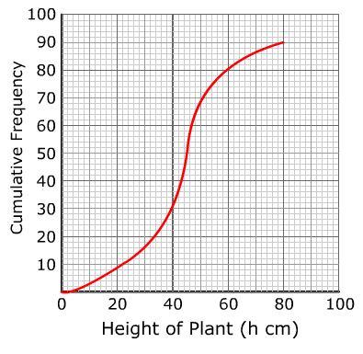Data set 3

The table shows the numbers of students in each year group of a school:

|  |  |  |  |  |  |  |
| --- | --- | --- | --- | --- | --- | --- |
|  | 7 | 8 | 9 | 10 | 11 |  |
| Number of students | 118 | 232 | 216 | 284 | 251 |  |

Data set 4

The table show the distribution, by age and gender, of staff in an office block:

|  |  |  |  |  |  |
| --- | --- | --- | --- | --- | --- |
|  | Age (x) years | | | |  |
|  | X < 20 | 20 < x < 30 | 30 < x < 40 | X > 40 |  |
| Men | 16 | 172 | 136 | 117 |  |
| Women | 18 | 191 | 142 | 137 |  |
|  |  |  |  |  |  |

Data set 5

The histogram shows the times taken to travel to college by students at a college.

90 students took between 20 and 35 minutes to travel to college.